Research title: template for empirical research (maximum 15 words)
1st author name¹, ^{2nd} author name²

¹Department and/or Faculty, University, City, Country
²Department and/or Faculty, University, City, Country
Received: month, year; Revised: Month, year;
Accepted: month, year; Published: month, year
Abstract
Abstract in English in one paragraph with a maximum English 200 words with no formula. The abstract should at least contain background, objectives, methods, results, and recommendations (if any). The abstract does not contain mathematical descriptions and statistical language.
Keywords: separate by a comma, contain 3-6 keywords, in English.
Introduction
The introduction is the background which is justification for the reasons research writing. References from various relevant and preferred articles from a scientific journal a maximum of 5 years backward and other sources that can be accounted for.
Theories and references of previous research that form the basis of writing are included in this section in the form of paragraphs rather than in the form of sub-chapters. Articles are written on A4 paper, top 3 cm, bottom 3 cm left side 3 cm, and right side 3 cm—Cambria font size 11. At the end of this section, a brief formula and the purpose of the discussion are presented in narrative form.
Provide a critical review of the relevant literature in a sequential argument so it leads to the development of the research question. The last paragraph in the introduction must clearly state the gap analysis or novelty contribution statement or novelty statement which explains the difference in the focus of the article study from previous research. State clearly the research aim or objective.
Methods
Contains the research design used (methods, types of data, data sources, data collection techniques, data analysis techniques, measurement of variables) written in the form of flowing paragraphs (not numbered). Writing the formula, the equations used are arranged on separate lines and numbered sequentially in parentheses (justify), and placed on the right margin parallel to the line. The author should avoid numbering, the use of semicolons (;) is highly recommended (written in paragraphs of essay form).
Presentation of formulas and information from formulas can be seen below:
Y = β₀ + b₁X₁ + b₂X₂+ .... b_{n}X_{n} + ε (1)
Where Y is the Entity of Entrepreneurship, β0 is a constant, b1, and b2 are regression coefficients, X1 is the need for achievement, X2 is self-efficacy and ε is the error term.
Result and Discussions
Contains research findings where the results and discussion are not separated. In this discussion, the authors examine the findings and refer to theoretical and empirical studies. Presentation of systematic discussion, critical analysis, and informative. The use of tables, figures, etc. is only as a support to clarify the discussion and is limited to supporters who are truly substantial, for example, tables of statistical test results, images of test results of models, etc.
The discussion is an argumentative result concerning the relevance of the results, theories, previous research, and empirical facts found, as well as showing the novelty of the findings. The use of a table is strongly recommended not to be too long, and if indeed it is necessary to include a long table then it can be included in the appendix. The use of subchapters in this discussion is expected to be in accordance with the research objectives.
Table 1. Table title with Cambria 11pt, align left, bold, Arabic numbering, and in series with other tables.
Variable | Cronbach's Alpha | Missing Data (%) | Rupiah (Rp) | AVE
Variable X | 0.888 | 2 | 1,000,000 | 0.639
Variable Y | 0.694 | 5 | 1,550,000 | 0.523
Variable Z | 0.885 | 7 | 900,000 | 0.638
Source: (if any) mention the source of the table with left indent and Cambria 9 pt. The source is not necessary if the data comes from the author's data processing. Align top-left for table body and alight center for table header.
- The table should be able to be revised, therefore we did not allow cut-and-paste tables from other sources such as statistics software, etc. The table should be rewritten and contain data that is suitable for discussion only.
- Table contents use 11pt Cambria.
- There are only 3 lines in the table: Top for the first row; Bottom line for the first row; and bottom line for the last row. No vertical line.
- The table used center alignment, with black and white (no colored table). If you are using colored tables then use gray gradation rather than solid color.
- Use a full-width window fit for the table.
- The first row (header row) uses align center alignment and for the second until the last row, use align center left.
- Dots (.) are used for decimal numbers and commas (,) are used to represent thousands, millions, etc.
- The table should not be truncated/cut pages. If the table is too long, then use a repeat header row for the next page.
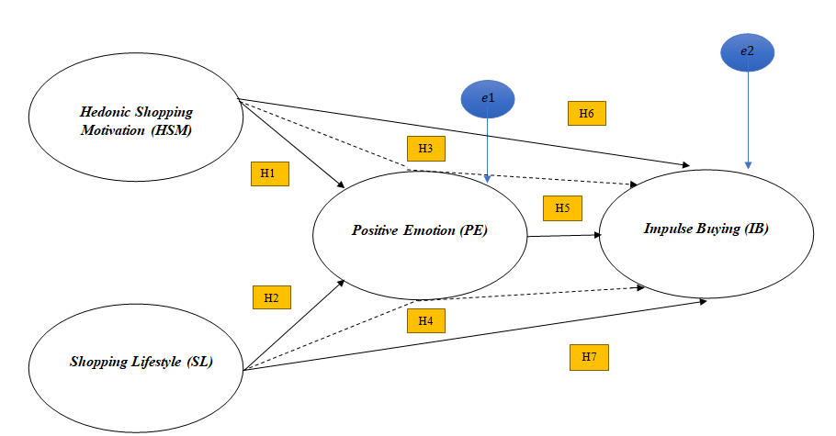
Figure title using Arabic numbers consecutively and placed before figure title.
Figure 1. Cambria 11pt, center and bold
Source: (if any) mention the source of the figure, Cambria 10 pt and center. The source is not necessary if the figure comes from the author's data processing.
- Figures used should be able to revised, therefore writer is not allowed to copy and paste figures as objects or pictures.
- The figure should be center-aligned. The diagram (representing numbers) uses gray gradation color and not solid color.
- No borderline around the figure.
- Source of the figure described in the text that explained the figure.
- The figure’s font is Cambria 11pt (the text on the image must be visible).
- If you are using an equation please do not use numbering.
- The equation or other unique character is typed with the font symbol 12pt (b, a, etc). If necessary use Microsoft equation to help in typing equations.
- If the author uses the X and Y axes to display the image, the axis lines must be black. The X and Y axes must also be clearly explained.
Conclusion
Contains conclusions formed in paragraphs (a two-paragraph maximum is recommended). Conclusions should be answers to research questions, and not expressed in statistical sentences. There is no need to explain again what has been discussed in the results and discussion section. Please add the limitations of the research and suggestions for future research.
Acknowledgement
Feel free to express your gratitude to the person(s) who helped you in accomplishing the research. Please keep the paragraph not more than 100 words.

References
The bibliography contains a list of journals, books, or other publications referred to in the manuscript. The minimum number of references is 20, and 80% of them are journal references and published in the last 10 years. Bibliography writing follows the American Psychological Association (APA) 6th. Writing a bibliography (and citations) must use the Mendeley Zotero or Endnote applications. (Mendeley's Tutorial: http://bit.ly/2vYEQGZ). Examples of writing a bibliography follow APA 6th as follows. The font size of the reference list is 11pt.
In the text use the following style examples:
- This was discussed by Smart (2016)…" – single author item
- This was discussed in full (Smart, 2016)" – single author item
- This was discussed in full (Smart & Burkart, 2016) – two authors
- This was discussed in full (Smart et al., 2016)…" – 3 or more authors
- This was discussed in full (P. Smart, 2016; S. Smart, 2017)…" where items have similar author names
- This was discussed in full (Smart, 2016a, 2016b)…" where two or more items are published in the same year
Reference examples:
Book
- Montgomery, D. C. (2012). Introduction to statistical quality control (7th ed.). Wiley.
Book chapter
- Slack, B. (2007). The terminalisation of seaports. In J. Wang, D. Olivier, T. Notteboom, & B. Slack (Eds.), Ports, cities, and global supply chains (pp. 41–50). Ashgate.
Journal article (References from journal articles must be accompanied by DOI)
- Badami, M. G., & Haider, M. (2007). An analysis of public bus transit performance in Indian cities. Transportation Research Part A: Policy and Practice, 41(10), 961–981. https://doi.org/10.1016/j.tra.2007.06.002
Conference proceedings
- Saraiji, R., Harb, A., & Hamdan, M. O. (2011). Performance of LED street lights in hot environments. In K. Domke & C. A. Brebbia (Eds.), Light in engineering, architecture and environment (pp. 147–158). WIT Press. https://doi.org/10.2495/LIGHT110131
- Brown, S., & Caste, V. (2004, May). Integrated obstacle detection framework. Paper presented at the IEEE Intelligent Vehicles Symposium, Detroit, MI.
Thesis or dissertation
- Suwetwattanakul, C. (2010). Developing a knowledge sharing model for the implementation of the learning organization in Thailand (Unpublished doctoral dissertation). Victoria University, Melbourne, Australia.
Internet documents
- Bown, J. (2019, December 17). How charity apps may be making us more generous. BBC News. https://www.bbc.com/news/business-50572939
Non-book and other formats
- Sidra Intersections. (2008). User guide-introduction. Akcelik & Associates Pty Ltd.
Standards
- European Committee for Standardization. (2005). Eurocode 3: Design of steel structures – Part 1-9: Fatigue (EN 1993-1-9). https://www.phd.eng.br/wp-content/uploads/2015/12/en.1993.1.9.2005-1.pdf
- International Organization for Standardization. (1998). Ergonomics of the thermal environment – Instruments for measuring physical quantities (ISO 7726:1998). Geneva, Switzerland.
Directives
- European Parliament, & Council of the European Union. (2009). Directive 2009/28/EC of the European Parliament and of the Council of 23 April 2009 on the promotion of the use of energy from renewable sources and amending and subsequently repealing directives 2001/77/EC and 2003/30/EC. https://eur-lex.europa.eu/legal-content/EN/ALL/?uri=CELEX:32009L0028

